Digitech Assignment - Sumo
Your objective for this assessment is to design, program and reflect on an algorithm that will run on a Micromelon Rover to compete in the Sumo Arena. Your sumo algorithm must make use of at least 3 of the rover sensors:

- Ultrasonic Sensor
- IR Distance Sensors
- Colour Sensors
- Accelerometer
- Gyroscope

What is Sumo?
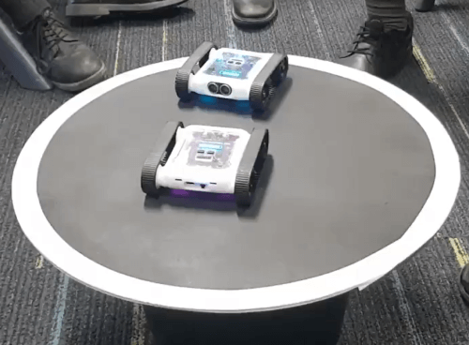
Sumo is an exercise where 2 or more robots battle in an arena attempting to defeat each other. All sumo matches will follow the attached rule sheet and be refereed by the teacher.

Assignment Items

Item | Marks | Due Date
Algorithm Design Flowchart | 10
Code Demonstration | 10
Reflection Questions | 5
Total Marks | 25

Algorithm Design Flowchart

The algorithm design flowchart will explain how you intend to program your sumo algorithm. It will be completed before you begin programming. The flowchart should outline the steps your Rover follows when executing your algorithm. Your flowchart should show where you’ve used:

- Branching ( IF/ELSE statements ) (3 marks)
- Iteration ( Loops ) (3 marks)
- Data from sensors, including what type of data the sensors generate. (4 marks)

Algorithm Demonstration

After completing your design flowchart you can now move onto programming the algorithm. Your algorithm does not have to be exactly the same as how you planned in the flow chart. Once finished, you may battle the three AI opponents. You cannot change your algorithm between battles. The opponents and marks for defeating the opponent in a best of 3 series are:

- Defeat the “EZ-PZ” AI 2 times out of 3 attempts (4 marks)
- Defeat the “Artemis” AI 2 times out of 3 attempts (3 marks)
- Defeat the “El Capitan” AI 2 times out of 3 attempts (3 marks)

Reflective Questions

Once you’ve finished your sumo battles you will reflect back on your algorithm design and determine how things went. Provide at least 3 sentence answers to the following three questions.

- What worked well in your algorithm and why?
- How would you improve your algorithm if you could?
- How would you change your algorithm if you could no longer use the rover’s colour sensor?

Sumo Battle Rule Sheet

Sumo Battle Setup
- All rovers start inside the arena with backs facing the centre of the ring.
- All competitors must start their code at the same time on the referee’s call.

Sumo Battle Rules
- Nobody is allowed to interfere with the rovers besides the referee.
- The battle is over once all but one rover is defeated. The final rover in the ring is declared the winner.
- The referee can call a stalemate if rovers are in an unwinnable situation for 10 seconds. The referee can either restart the match or declare a draw.
- A rover is defeated when one of the following conditions are met:
- It has been knocked out
- It has been incapacitated.
- It is disqualified by the referee
The referee will remove rovers from the battle once they have been defeated.

What is a Knockout
When the majority of the rover’s is outside the arena. The referee decides when a knock has happened.

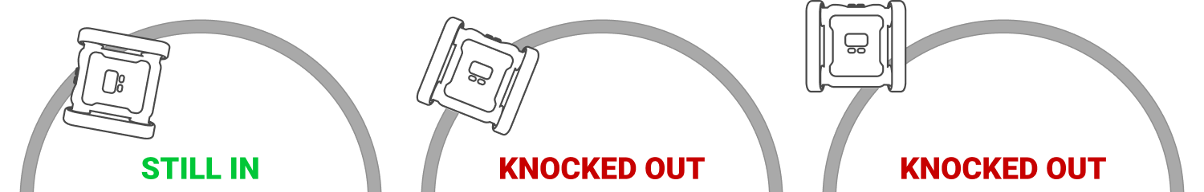

What is Incapacitation
A rover is considered incapacitated if:
- The rover is unable to move on it’s own, e.g. tracks fallen off or obstruction from attachment
- The rover’s program has stopped running.

What is a Disqualification
The referee can disqualify a rover if the rover’s code does not move. The rover must attempt to battle while in the match.

