Sumo Battle Rule Sheet

Sumo Battle Setup
- All rovers start inside the arena with backs facing the centre of the ring.
- All competitors must start their code at the same time on the referee’s call.

Sumo Battle Rules
- Nobody is allowed to interfere with the rovers besides the referee.
- The battle is over once all but one rover is defeated. The final rover in the ring is declared the winner.
- The referee can call a stalemate if rovers are in an unwinnable situation for 10 seconds. The referee can either restart the match or declare a draw.
- A rover is defeated when one of the following conditions are met:
- It has been knocked out
- It has been incapacitated.
- It is disqualified by the referee
The referee will remove rovers from the battle once they have been defeated.

What is a Knockout
When the majority of the rover’s is outside the arena. The referee decides when a knock has happened.

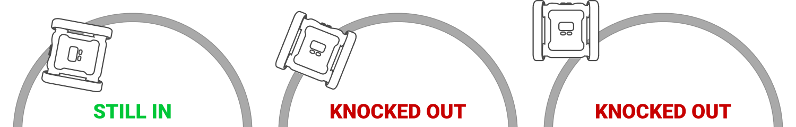

What is Incapacitation
A rover is considered incapacitated if:
- The rover is unable to move on it’s own, e.g. tracks fallen off or obstruction from attachment
- The rover’s program has stopped running.

What is a Disqualification
The referee can disqualify a rover if the rover’s code does not move. The rover must attempt to battle while in the match.

